### **AI-powered Nutrition Analyzer for Fitness Enthusiasts**

**1. INTRODUCTION**

Food is essential for human life and has been the concern of many healthcare conventions. Nowadays new dietary assessment and nutrition analysis tools enable more opportunities to help people understand their daily eating habits, exploring nutrition patterns and maintain a healthy diet. It is vital part of analytical chemistry that provides information about the chemical composition, processing quality control and contamination of food. Here the user can capture the image will be sent the trained model. The model analyses the image and detect the nutrition based on fruits like (sugar, Protein, Calories, etc.).

**1.1 Project Overview**

As the world grows more fitness-conscious with passing time, the demand for technological solutions to cater to this burgeoning demand is diversifying. In India, this global trend has had a positive impact on scores of startups and websites catering to this segment. AI and its various subsets have been leveraged by these platforms to identify the calorie intake and also to make food recommendations for a healthy diet. In most cases, what we see is that these platforms act as a data repository where while providing real-time information to its users, it also makes available to numerous clients who work in this field for a determined rate. In this article, we take a look at the top AI-based online platforms which make use of AI and other deep learning technologies to provide a real-time updates about nutrition intake. The main aim of the project is to building a model which is used for classifying the fruit depends on the different characteristics like color, shape.

**1.2 Purpose**

The main aim of the project is to building a model which is used for classifying the fruit depends on the different characteristics like colour, shape, texture etc. Here the user can capture the images of different fruits and then the image will be sent the trained model. The model analyses the image and detect the nutrition based on the fruits like (Sugar, Fibre, Protein, Calories, etc.).

**2. LITERATURE SURVEY**

**2.1** **Existing problem**

In the short term, poor nutrition can contribute to **stress, tiredness and our capacity to work**, and over time, it can contribute to the risk of developing some illnesses and other health problems such as: being overweight or obese. Tooth decay ,high blood pressure. There are now strong links between low intakes of particular nutrients and the **risk of developing chronic disease including some cancers, heart disease, diabetes, osteoporosis and depression**. During pregnancy, insufficient nutrient intake can have long-term health implications for the health of the child.

**2.2 References**

1. Published on April 8, 2019 From Gynaecology to Data Science : The journey of Dr Nitin Paranjape. Analyticsindiamag.com, Akshaya Asokan.
2. Melina cote and Benoit Lamarche , Applied Physiology , Nutrition and Metabolism 15
3. Deloitte(2017) the hospital of the future URL www.deloitte.com/us/global-hospital-of-the future (accessed August 9,2019)
4. INQA (Ed.)(2015) intelligente technik in der beruflichen pfege.von den chance und Risiken einer Pflege 4.0.
5. McCarthy, J., Minsky, M. L., Rochester, N., & Shannon, C. E. (2006). A Proposal for Dartmouth Summer Research Project on Artificial Intelligence. AI Magazine, 27(4), 12-14. https://www.aaai.org/ojs/index.php/aimagazine/ article/view/1904/1802.
6. Lalwani, P.(2019). The ethics of AI in HR : what does it take to build an ai ethics framework? https://www.hrtechnoologist.com/articles/digital-transformation/the-ethics-of-ai-in-hr/
7. Kozan, K.(2017), 3 simple step for improving your candidate engagement, <https://ideal.com/candidate-engagement>.
8. Johnson K.W., Torres Soto J., Glicksberg B.S., Shameer K., Miotto R., Ali M., Ashley E., Dudley J.T. Artificial intelligence in cardiology. *J. Am. Coll. Cardiol.*2018;71:2668–2679. doi: 10.1016/j.jacc.2018.03.521. [[PubMed](https://pubmed.ncbi.nlm.nih.gov/29880128)] [[CrossRef](https://doi.org/10.1016%2Fj.jacc.2018.03.521" \t "_blank)] [[Google Scholar](https://scholar.google.com/scholar_lookup?journal=J.+Am.+Coll.+Cardiol.&title=Artificial+intelligence+in+cardiology&author=K.W.+Johnson&author=J.+Torres+Soto&author=B.S.+Glicksberg&author=K.+Shameer&author=R.+Miotto&volume=71&publication_year=2018&pages=2668-2679&pmid=29880128&doi=10.1016/j.jacc.2018.03.521&)]
9. Hessler G., Baringhaus K.-H. Artificial intelligence in drug design. *Molecules.*2018;23:2520. doi: 10.3390/molecules23102520. [[PMC free article](https://www.ncbi.nlm.nih.gov/pmc/articles/PMC6222615/)] [[PubMed](https://pubmed.ncbi.nlm.nih.gov/30279331)] [[CrossRef](https://doi.org/10.3390%2Fmolecules23102520" \t "_blank)] [[Google Scholar](https://scholar.google.com/scholar_lookup?journal=Molecules&title=Artificial+intelligence+in+drug+design&author=G.+Hessler&author=K.-H.+Baringhaus&volume=23&publication_year=2018&pages=2520&pmid=30279331&doi=10.3390/molecules23102520&)]
10. Heydarian H., Adam M.T.P., Burrows T., Collins C.E., Rollo M.E. Assessing eating behaviour using upper limb mounted motion sensors: A systematic review. *Nutrients.*2019;11:1168. doi: 10.3390/nu11051168. [[PMC free article](https://www.ncbi.nlm.nih.gov/pmc/articles/PMC6566929/)] [[PubMed](https://pubmed.ncbi.nlm.nih.gov/31137677)] [[CrossRef](https://doi.org/10.3390%2Fnu11051168" \t "_blank)] [[Google Scholar](https://scholar.google.com/scholar_lookup?journal=Nutrients&title=Assessing+eating+behaviour+using+upper+limb+mounted+motion+sensors:+A+systematic+review&author=H.+Heydarian&author=M.T.P.+Adam&author=T.+Burrows&author=C.E.+Collins&author=M.E.+Rollo&volume=11&publication_year=2019&pages=1168&pmid=31137677&doi=10.3390/nu11051168&)]
11. Demirci F., Akan P., Kume T., Sisman A.R., Erbayraktar Z., Sevinc S. Artificial neural network approach in laboratory test reporting: Learning algorithms. *Am. J. Clin. Pathol.*2016;146:227–237. doi: 10.1093/ajcp/aqw104. [[PubMed](https://pubmed.ncbi.nlm.nih.gov/27473741)] [[CrossRef](https://doi.org/10.1093%2Fajcp%2Faqw104" \t "_blank)] [[Google Scholar](https://scholar.google.com/scholar_lookup?journal=Am.+J.+Clin.+Pathol.&title=Artificial+neural+network+approach+in+laboratory+test+reporting:+Learning+algorithms&author=F.+Demirci&author=P.+Akan&author=T.+Kume&author=A.R.+Sisman&author=Z.+Erbayraktar&volume=146&publication_year=2016&pages=227-237&pmid=27473741&doi=10.1093/ajcp/aqw104&)]

**2.3Problem Statement Definition**

The amount of physical activity you need depends on your individual fitness goals and your current fitness level. It’s important to start within your abilities and listen to your body’s cues in terms of pain and injury. Obesity is a common health issue that is defined by having a high percentage of body fat. Being overweight or obese increases your chances of dying from hypertension, coronary heart disease, sleep apnea, and endometrial, breast, prostate, and colon cancers. Junk foods are high in calorie but low in nutrition value and lead to an excess metabolic weight leading to obesity. An obese individual is prone to life-threatening diseases which are not only limited to cholesterol or diabetes but also can cause stoke and NCDs. Overtraining may wear down the immune system. It Increases cardiovascular stress. Incorrect workouts may cause sprains, strains, fracture and other painful injury.

**3. IDEATION & PROPOSED SOLUTION**

**3.1 Empathy Map Canvas**

**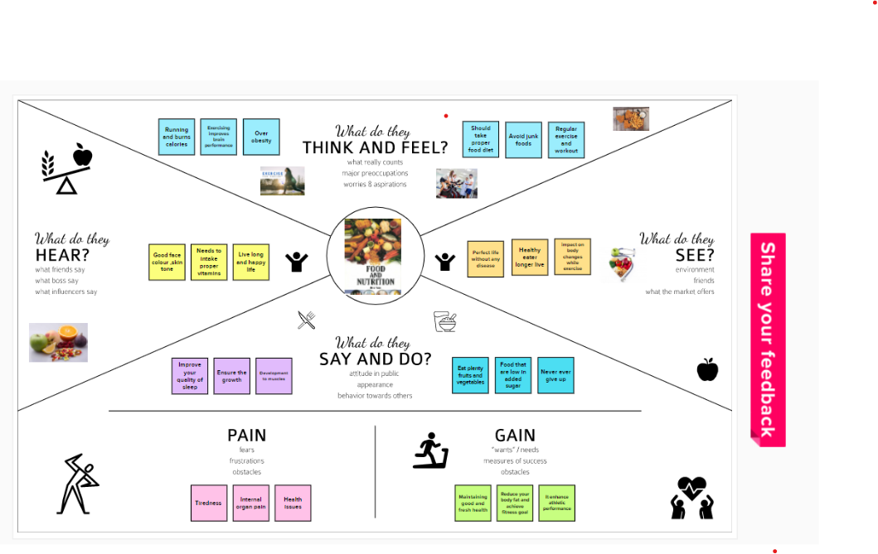**

**3.2 Ideation & Brainstorming**

**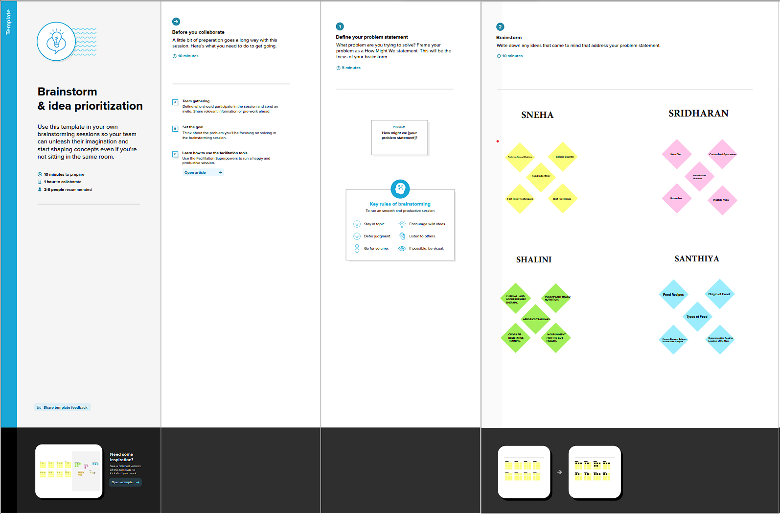**

**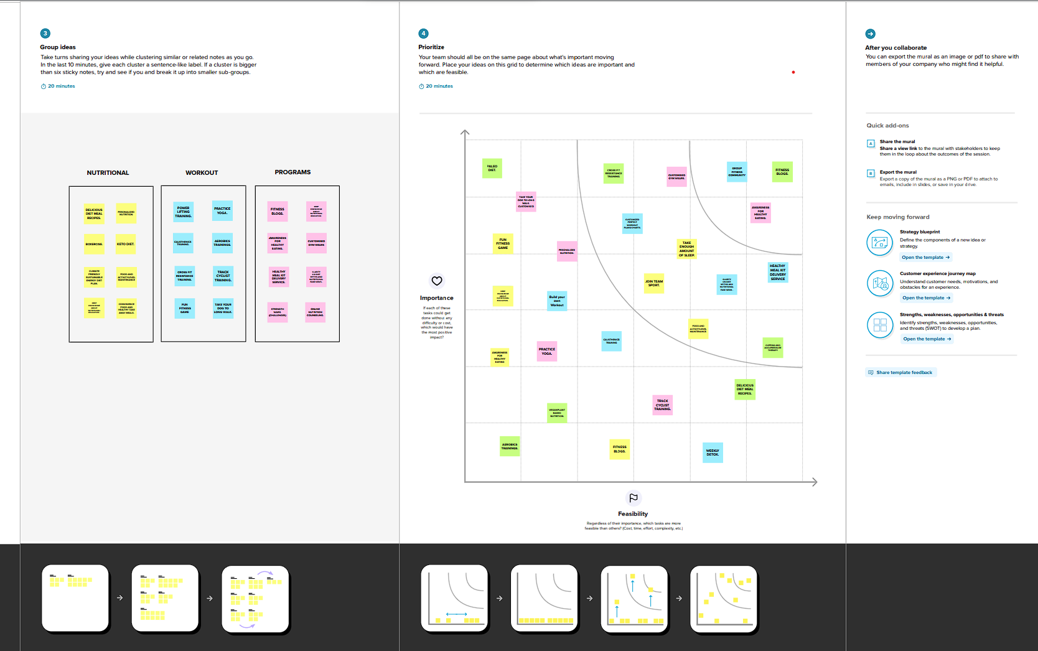**

**3.3 Proposed Solution**

|  |  |  |
| --- | --- | --- |
| **S.NO** | **PARAMETER** | **DESCRIPTION** |
| 1 | Problem Statement (Problem to be solved) | How to intake suitable nutrition with correct guidance and weight level  should be manage through tracking our day to day fitness. |
| 2 | Idea / Solution Description | To track fitness level and Analyze the nutrition level of foods like fruits , vegetables . It helps to identify the proportion of vitamins. |
| 3 | Novelty/Uniqueness | Giving a individual Food/health  Schedule According to their body conditions |
| 4 | Social impact/Customer Satisfaction | Low expenditure ,easy to follow without affecting their personal time. |
| 5 | Business model  (Revenue Model) | Free platform for all users. For specific  guidance users want to pay |
| 6 | Scalability of the solution | Notifying motivational quote’s to lead a healthy routine |

**3.4Problem Solution fit**

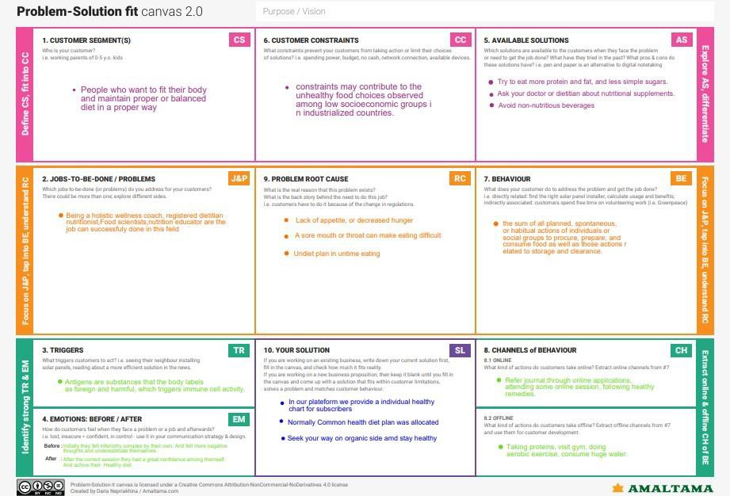

**4.REQUIREMENT ANALYSIS**

**4.1Functional requirement**

* It will generate the diet plan as well as monitor the user’s health to classify the category of the disease and to create the diet plan. It will also reduce the cost of consulting the person nutritionist.
* The task of food detection/classification is not easy as it seems. All possible options related to the given Image.

1. Image classification, object detection, segmentation, face recognition.
2. Classification of crystal structure using a convolutional neural network.

* Computer-Assisted Nutritional Recognize Food Images – In order to solve this issue, a brand-new Convolutional Neural Network (CNN)- based food picture identification system was created, as described in this study. We utilized our suggested strategy on two sets of actual food picture data.
* Here the user can capture the images of different fruits and then the image will be sent to the trained model. The model analyzes the image and detects the nutrition based on the fruits like (Sugar, Fiber, Protein, Calories, etc.)
* The Ultimate Workout at Home Solution This fitness AI software is designed with personalized training regimens for each individual. It began as “gym only software,” but has now improved its system to satisfy “at home fitness” expectations.
* You take a picture, dial in data such as whether you are eating breakfast or lunch and add a quick text label, and the app estimates the calorie content.

This software collaborated with IBM’s natural language capability to provide 24-hour assistance and dietary recommendations.

For Example:

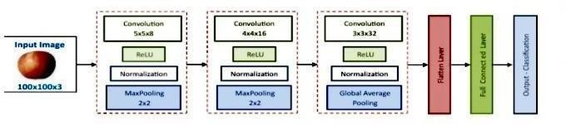

* The comparison of the proposed model with the conventional models shows that the results of this model are exceptionally good and promising to use in real-world applications. This sort of higher accuracy and precision will work to boost the machine’s general efficiency in fruit recognition more appropriately.
* A generic model for the dietary protein requirement (as with any nutrient) defines the requirement in terms of the needs of the organism,
* i.e. metabolic demands, and the dietary amount which will satisfy those needs, i.e. efficiency of utilization, thus: dietary requirement = metabolic demand/efficiency of utilization.

**5.PROJECT DESIGN**

**5.1 Data Flow Diagrams** 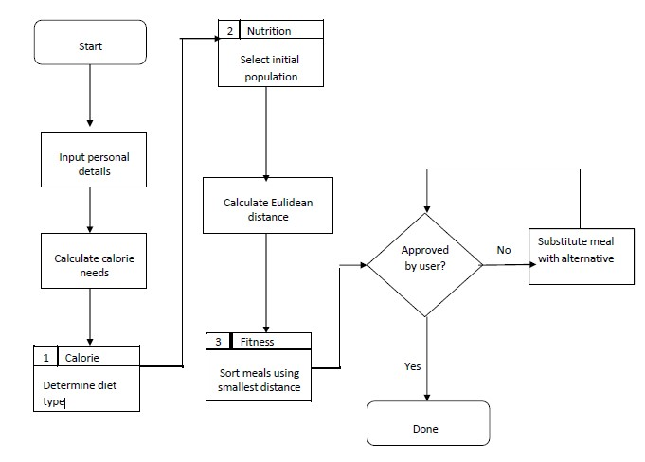

**5.2Solution & Technical Architecture**

* Nowadays new dietary assessment and nutrition analysis tools enable more opportunities to help people understand their daily eating habits, exploring nutrition patterns and maintain a healthy diet.
* Nutritional analysis is the process of determining the nutritional content of food.
* The main aim of the project is to building a model which is used for classifying the fruit depends on the different characteristics like colour, shape, texture etc.
* Food is essential for human life and has been the concern of many healthcare conventions.
* It is a vital part of analytical chemistry that provides information about the chemical composition, processing, quality control and contamination of food.

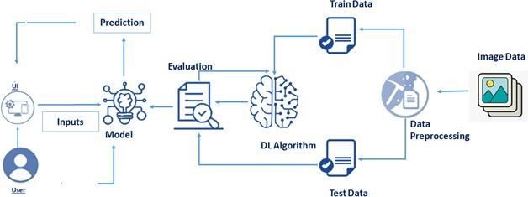

**6. PROJECT PLANNING & SCHEDULING**

**6.1Sprint Planning & Estimation**

|  |  |  |  |  |  |  |
| --- | --- | --- | --- | --- | --- | --- |
| **Sprint** | **Total Story Points** | **Duration** | **Sprint Start Date** | **Sprint End Date (Planned)** | **Story Points Completed (as on Planned End Date)** | **Sprint Release Date (Actual)** |
| Sprint-1 | 20 | 6 Days | 24 Oct 2022 | 29 Oct 2022 | 20 | 29 Oct 2022 |
| Sprint-2 | 20 | 6 Days | 31 Oct 2022 | 05 Nov 2022 | 20 | 03 Nov 2022 |
| Sprint-3 | 20 | 6 Days | 07 Nov 2022 | 12 Nov 2022 | 20 | 10 Nov 2022 |
| Sprint-4 | 20 | 6 Days | 14 Nov 2022 | 19 Nov 2022 | 20 | 17 Nov 2022 |

**6.2Sprint Delivery Schedule**

|  |  |  |  |  |  |  |
| --- | --- | --- | --- | --- | --- | --- |
| Sprint | Functional Requirement (Epic) | User Story Number | User Story / Task | Story Points | Priority | Team Members |
| Sprint-1 | Data Collection | USN-1 | Download Food Nutrition Dataset | 2 | Medium | SANTHIYA |
| Sprint-1 | Data Preprocessing | USN-2 | Importing The Dataset into Workspace | 1 | Low | SHALINI |
| Sprint-1 |  | USN-3 | Handling Missing Data | 3 | Medium | SNEHA |
| Sprint-1 |  | USN-4 | Feature Scaling | 3 | Low | SRIDHARAN |
| Sprint-1 |  | USN-5 | Data Visualization | 3 | Medium | SNEHA |
| Sprint-1 |  | USN-6 | Splitting Data into Train and Test | 4 | High | SHALINI |
| Sprint-1 |  | USN-7 | Creating A Dataset with Sliding Windows | 4 | High | SANTHIYA |
| Sprint-2 | Model Building | USN-8 | Importing The Model Building Libraries | 1 | Medium | SRIDHARAN |
| Sprint-2 |  | USN-9 | Initializing The Model | 1 | Medium | SHALINI |

|  |  |  |  |  |  |  |
| --- | --- | --- | --- | --- | --- | --- |
| Sprint-2 |  | USN-10 | Adding LSTM Layers | 2 | High | SNEHA |
| Sprint-2 |  | USN-11 | Adding Output Layers | 3 | Medium | SANTHIYA |
| Sprint-2 |  | USN-12 | Configure The Learning Process | 4 | High | SHALINI |
| Sprint | Functional Requirement (Epic) | User Story Number | User Story / Task | Story Points | Priority | Team Members |
| Sprint-2 |  | USN-13 | Train The Model | 2 | Medium | SHALINI |
| Sprint-2 |  | USN-14 | Model Evaluation | 1 | Medium | SANTHIYA |
| Sprint-2 |  | USN-15 | Save The Model | 2 | Medium | SNEHA |
| Sprint-2 |  | USN-16 | Test The Model | 3 | High | SRIDHARAN |
| Sprint-3 | Application Building | USN-17 | Create An HTML File | 4 | Medium | SHALINI |
| Sprint-3 |  | USN-18 | Build Python Code | 4 | High | SANTHIYA |
| Sprint-3 |  | USN-19 | Run The App in Local Browser | 4 | Medium | SNEHA |
| Sprint-3 |  | USN-20 | Showcasing Prediction On UI | 4 | High | SRIDHARAN |
| Sprint-4 | Train The Model On IBM | USN-21 | Register For IBM Cloud | 4 | Medium | SHALINI |
| Sprint-4 |  | USN-22 | Train The ML Model On IBM | 8 | High | SNEHA |
| Sprint-4 |  | USN-23 | Integrate Flask with Scoring End Point | 8 | High | SANTHIYA |

**7.CODING & SOLUTIONING (Explain the features added in the project along with code)**

**7.1 Feature 1** 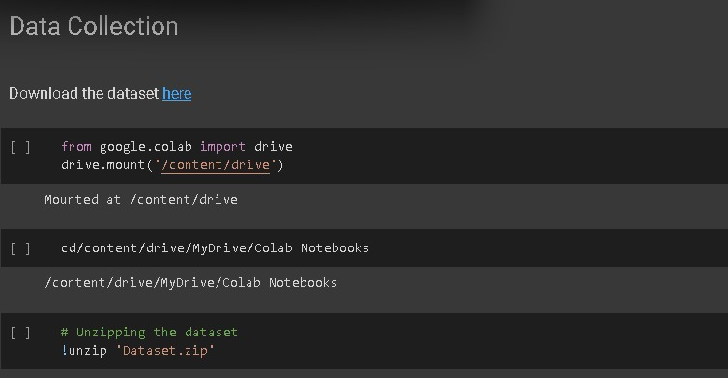

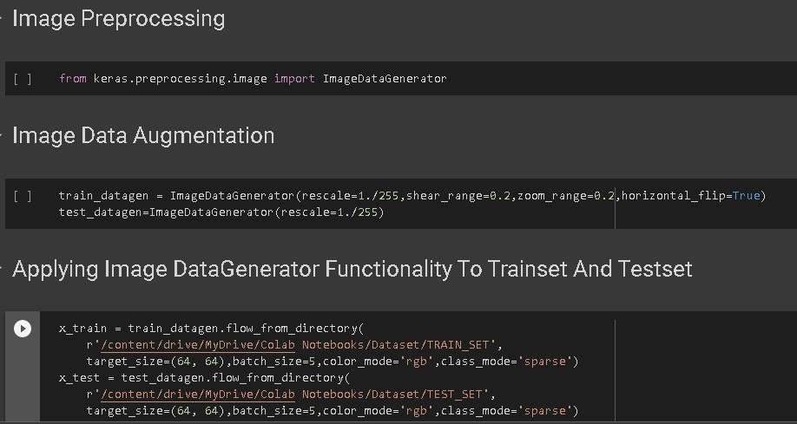

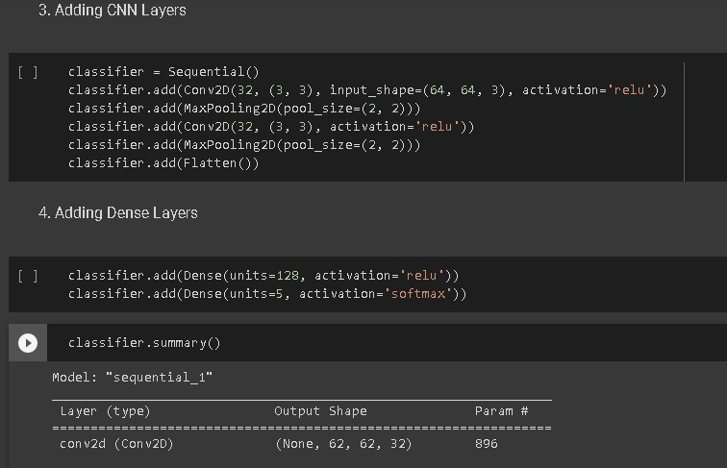

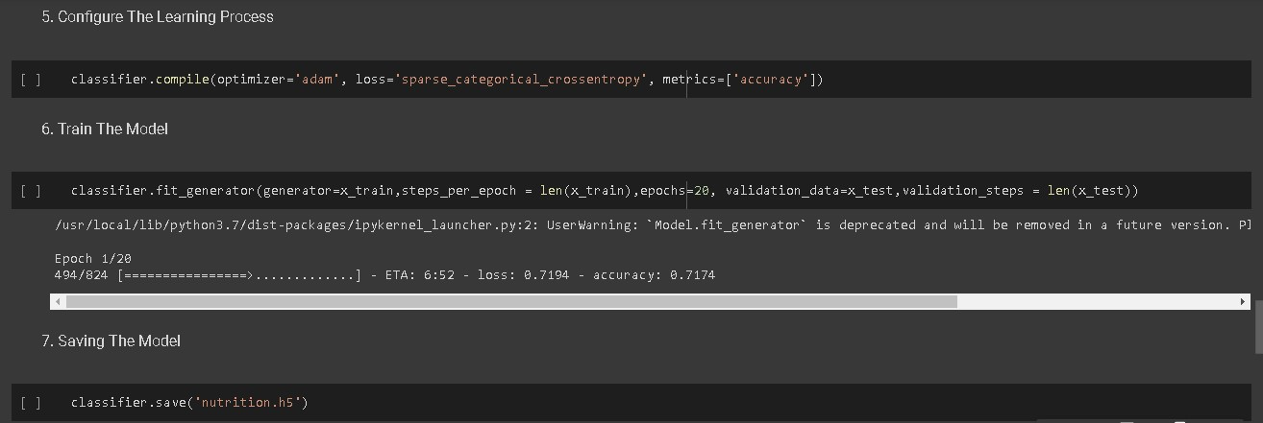

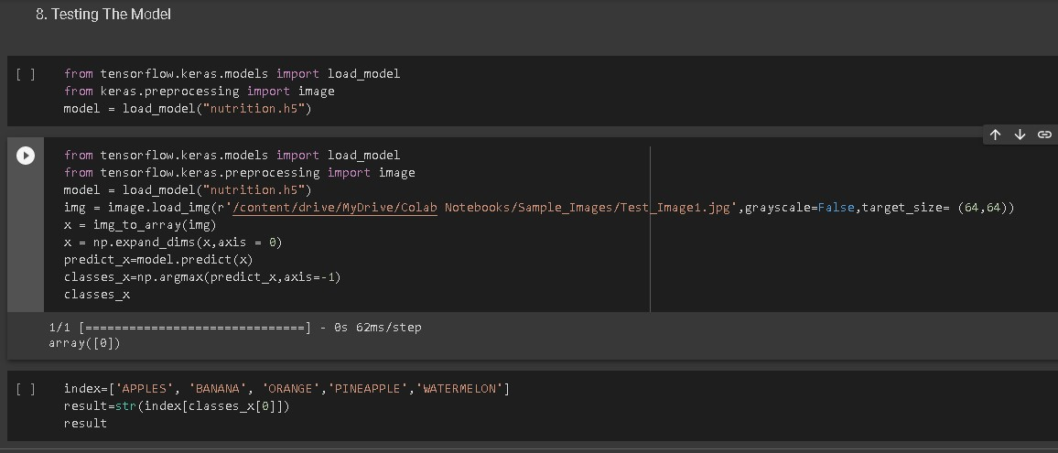

**7.2Feature 2**

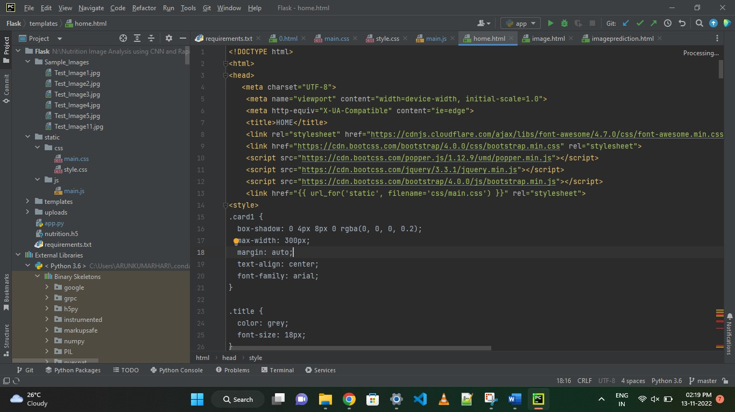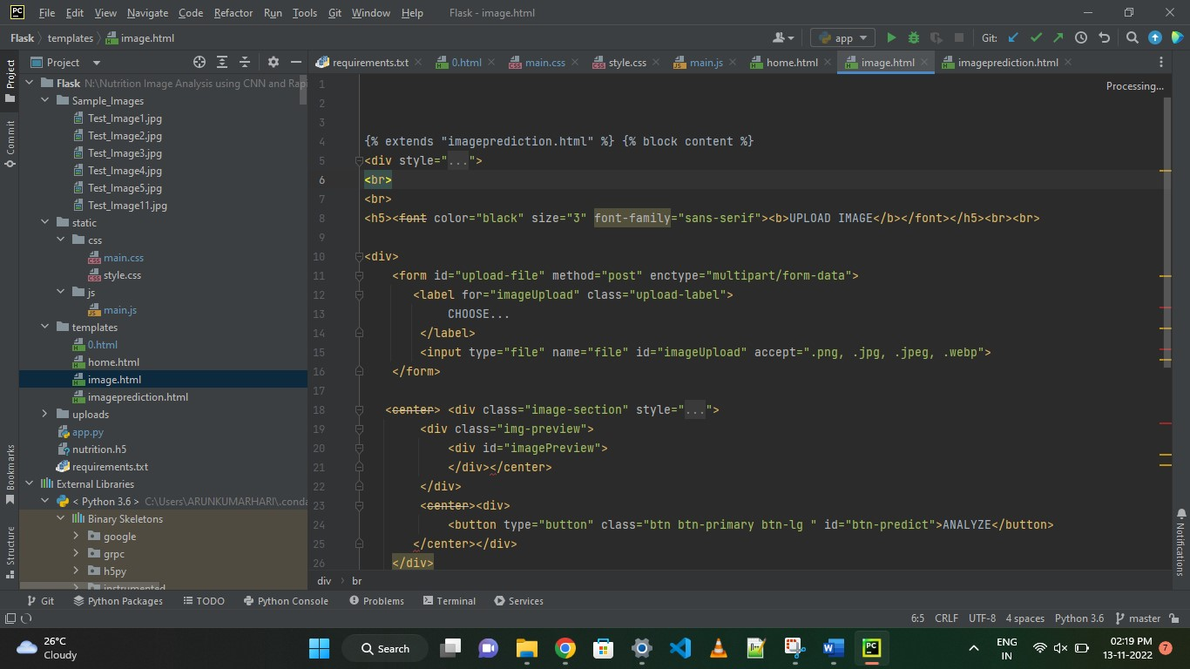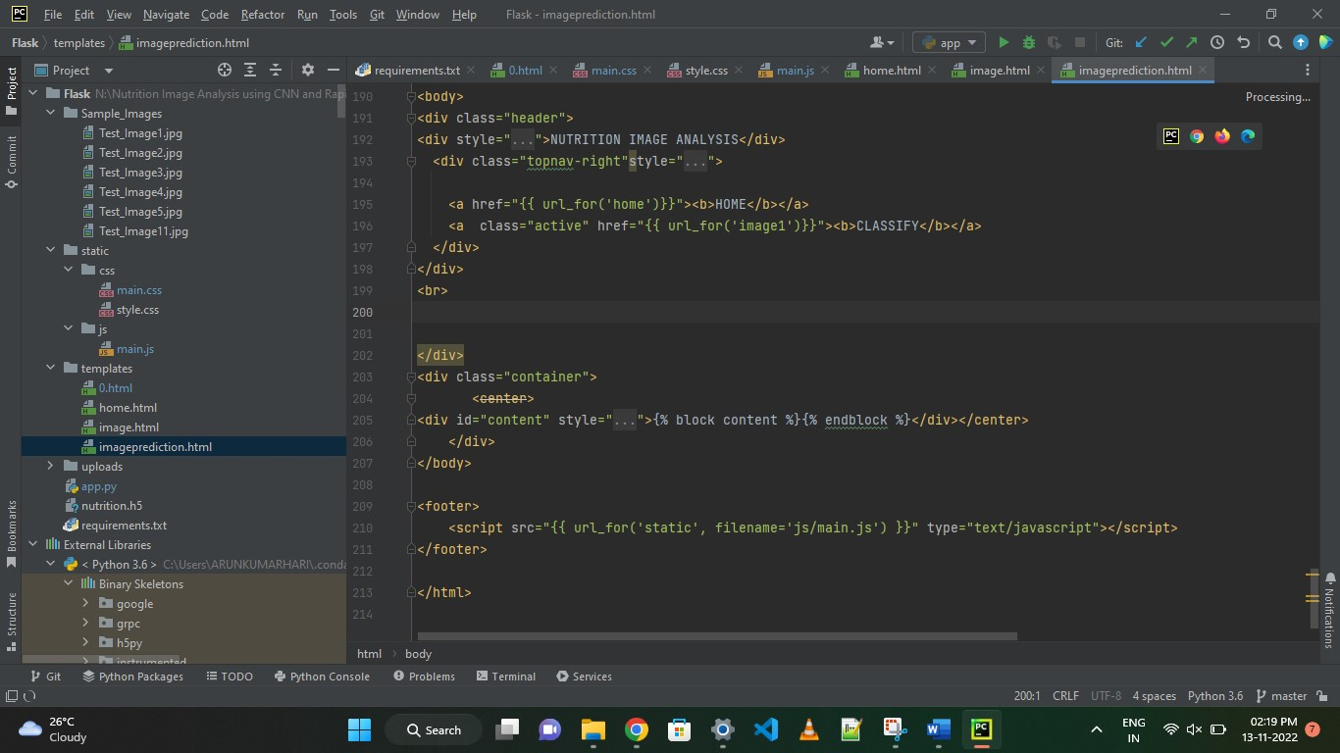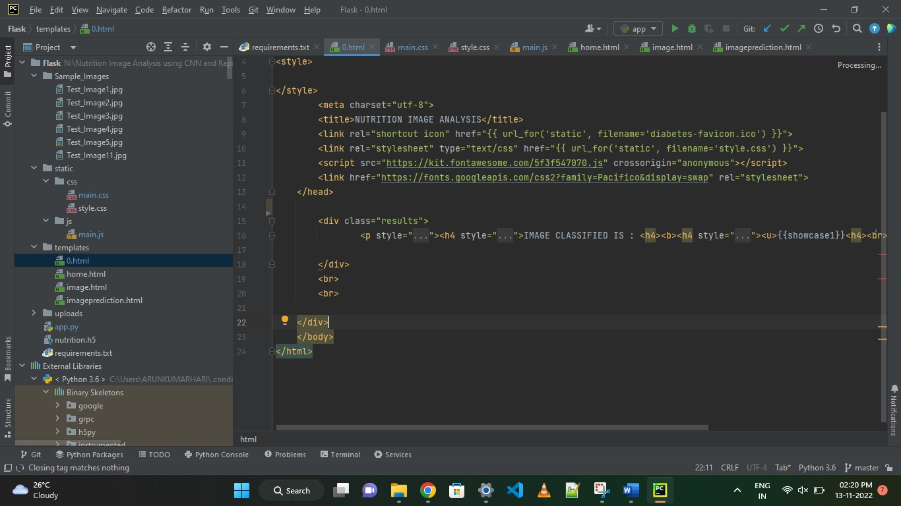

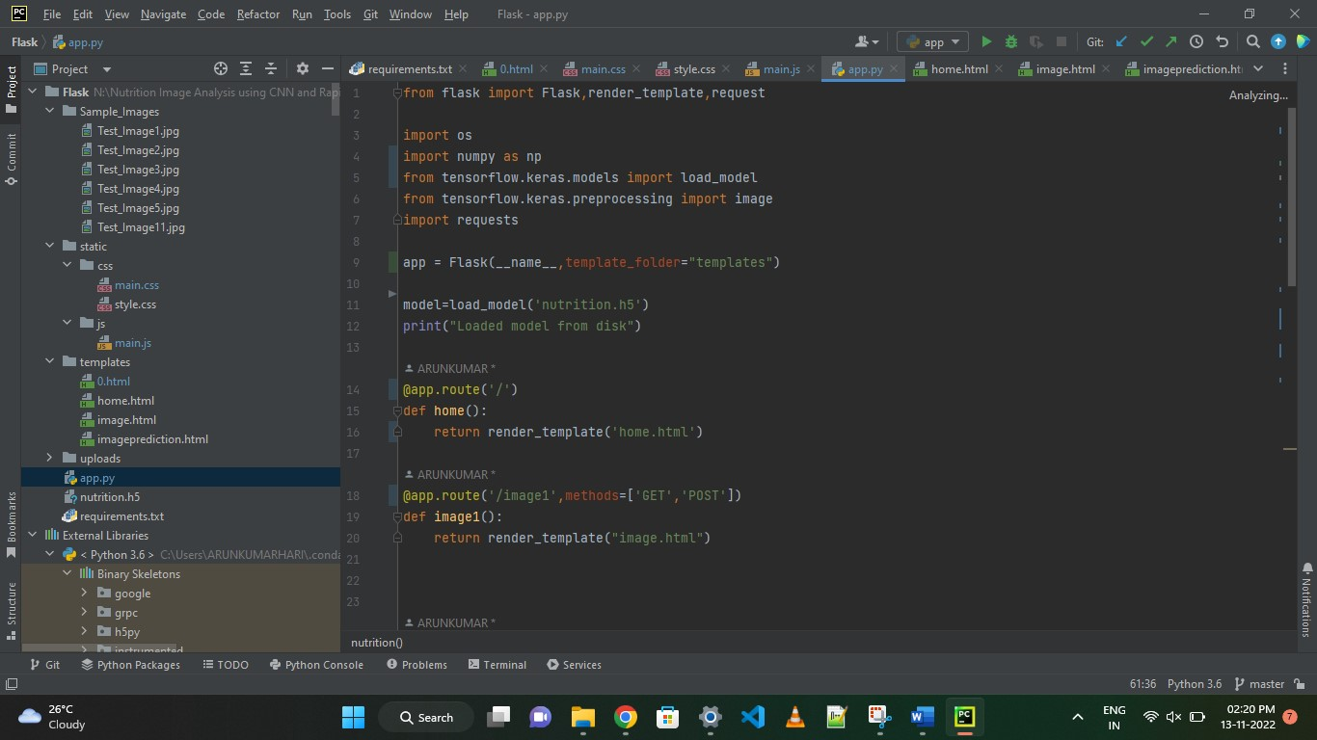

Database Schema (if Applicable)

**8.TESTING**

**8.1Test Cases**

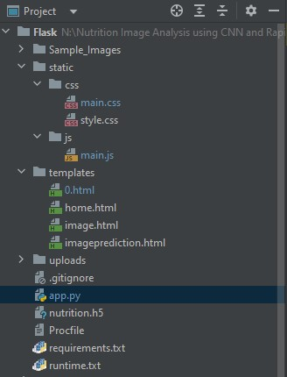

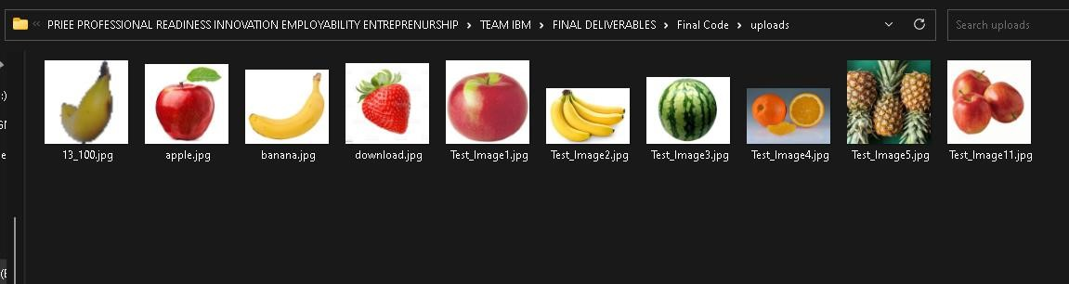

**8.2User Acceptance Testing**

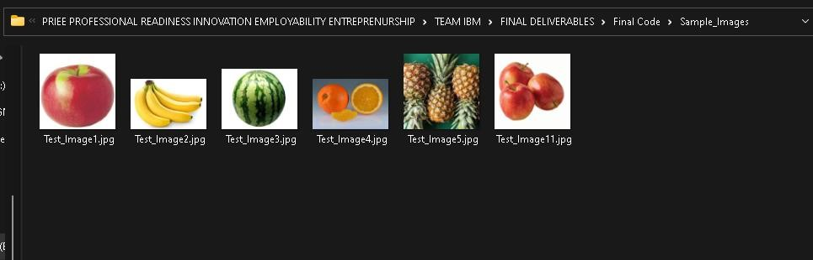

**9.RESULTS**

**9.1Performance Metrics**

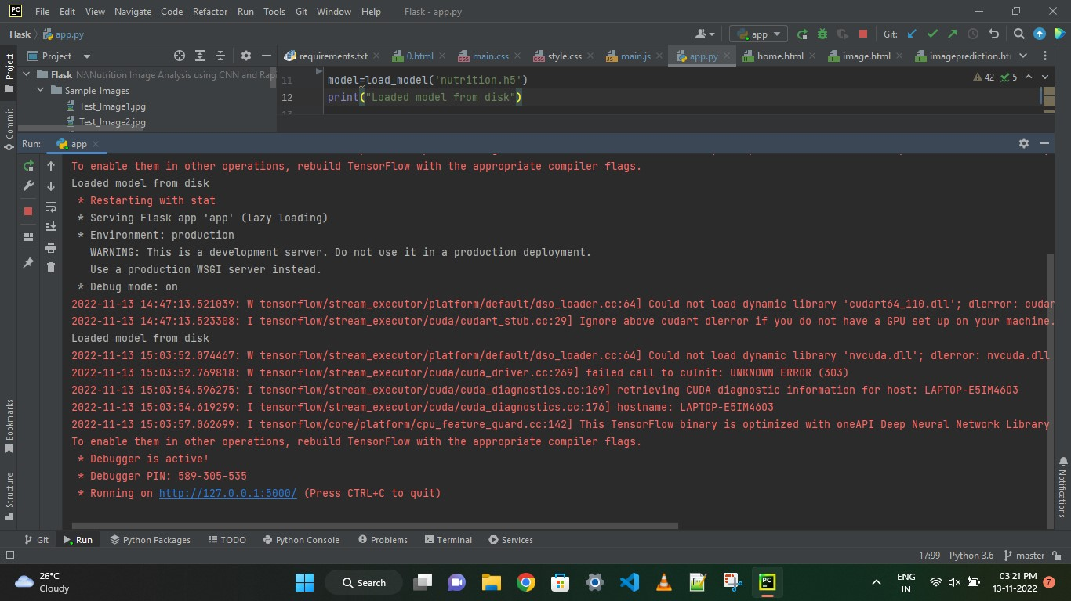

**10.ADVANTAGES**

Advantages-Nowadays new dietary assessment and nutrition analysis tools **enable more opportunities to help people understand their daily eating habits, exploring nutrition patterns and maintain a healthy diet**. Nutritional analysis is the process of determining the nutritional content of food.

**11.CONCLUSION**

Thus powered nutrition analyzer for fitness enthusiasts good nutrition promotes not only better physical healthy and reduced susceptibility to disease, but has also been demonstrated to contribute to cognitive development and academic success. Left to their own devices, children will not automatically select healthy food. A balance diet and appropriate meal timings are important for healthy body and mind. Most countries nowadays implement health **s**education program in schools which include feeding to students, vitamin and mineral supplementation.

**12.FUTURE SCOPE**

AI is revolutionizing the health industry. It is majorly used in improving marketing and sales decisions, AI is now also being used to reshape individual habits. In future we don’t want to go to gym and do any diets. By using this nutrition fitness analyzer we can maintain our diet plans without any help from others and we can lead a happy and healthy life with good wealth.AI can easily track health behaviors and repetitive exercise patterns and use the data to guide you towards your fitness journey and diet plans.

**13.APPENDIX**

GitHub & Project Demo Link

https://github.com/IBM-EPBL/IBM-Project-52808-1661157749

Demo link

<https://youtu.be/j5vTQUswfUQ>